Driffield & Rural Ward and
East Wolds & Coastal Ward Update -
October 2021 Issue

Meet Your Team

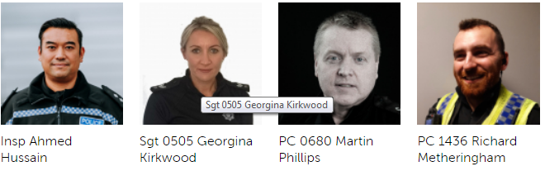

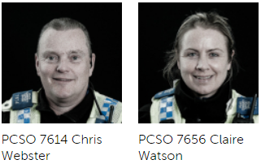
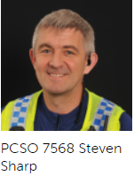

Detailed crime and ASB data for your area can be obtained by visiting www.police.uk and entering your postcode into the ‘What’s happening in your area?’ section.

For current information and guidance on Covid-19 please visit https://www.gov.uk/coronavirus. This is a ‘one stop shop’ for Covid-19 which is constantly being updated with the latest guidance from the government and health officials. Further information and links can be found on our website by visiting https://www.humberside.police.uk/coronavirus-advice-and-information

If after viewing the current information and guidance you still have concerns in relation to an individual, business or group of people not following the rules relating to Covid breaches please report via 101.
Can I also ask that if you become aware of persons living in your communities that you deem are vulnerable or isolated who are not receiving any support from Government agencies or volunteer organisations you please let us know via our email address:
Communities-BridlingtonTeamALLSTAFF@humberside.pnn.police.uk

- What’s Happening In Your Area?

Shop Theft
There has been an increase in shop theft in Driffield town centre as Covid restrictions have been relaxed and the number of retail shoppers has increased. This has been more notable in the larger retail outlets such as Boots, Tesco's and Wilko's. We will continue to work with businesses to produce ‘best evidence’ when reporting crime and conduct high visibility patrols. We will review each recorded crime and encourage more shops to join Shopwatch and social media initiatives.
Drug Use and dealing
Intelligence indicates an increase in the supply and use of controlled substances within Driffield and the surrounding area. We will look to obtain Search Warrants where applicable led by intelligence. We will be looking to conduct a Drugs dog operation using stop & search powers to target licence premises and other areas used for drug taking.
Rural Crime
As Covid restrictions have relaxed and the harvest is taken in historically ASB, poaching and inquisitive crime increases. We will Increase high visibility patrols in line with Operation GALILEO working with partner agencies including Farmwatch and The Rural Task Force. We will continue to utilise My Community Alert and social media. We will conduct visits to rural businesses to promote crime prevention.
Humbertalking
Humber Talking is still being undertaken in the Driffield area. We will be adhering to Social distancing guidance and will not be entering houses but speaking to members of the public who want to take part on their doorsteps. If you would rather participate online and highlight any issues you think the Police should be dealing with please visit the website www.mycommunityalert.co.uk/humbertalking your responses help us better understand our area and prioritise issues to be tackled.

- Meet your officers –

We encourage everyone to follow Government Advice on Coronavirus at https://www.gov.uk/coronavirus

Rural surgeries are set to continue Late October 2021 with the local Community team pitching up in various locations around the Driffield area, giving general crime prevention and advice on policing matters. We will continue to update Facebook and Twitter with dates as they become available. Come and see us!

Social distancing and Covid protocols will be in place.

Stay informed through our social media channels, find us on Twitter, Facebook and Instagram @humberbeat. For incidents that don’t require an immediate response call our non-emergency 101 line. You can also report non-emergency crimes online via our reporting portal. In an emergency always dial 999.

Police Station Front Counters – Driffield - WE ARE OPEN

Our normal opening hours are Tuesday, Wednesday, Thursday 9am-5pm (Closed 1-2pm).

- News and Appeals

Horse Watch relaunches in Holderness

We are pleased to report that Horse Watch has recently been relaunched and we are keen for new members to join. Please take a look at the below link for full details.

https://www.humberside.police.uk/news/horse-watch-relaunches-holderness

You can contact the Horse Watch team on the community email address: withernsea@humberside.pnn.police.uk

Please be aware that the Horse Watch inbox is for non-urgent general enquiries only and is not monitored daily. To report incidents, please call the police on 101.

£1.2mil worth of drugs seized during organised crime disruption

A large, organised crime group growing and distributing cannabis in Hull and surrounding East Riding villages has been the target of an operation, which started on Wednesday 8th September and ended today (Monday 13 September), aimed at disrupting organised criminality and taking drugs off the streets.
A total of 39 addresses were subject to warrants or searches under police powers over four days, at addresses across Hull as well as, Welton, Brough and even a yacht!
These resulted in ten arrests, with six charged, all as being concerned in the production of cannabis. Those arrested who have not been charged have been released under investigation, pending further enquiries into their involvement in organised criminality.

https://www.humberside.police.uk/news/%C2%A312mil-worth-drugs-seized-during-organised-crime-disruption

Warnings over catalytic converter thefts

We would like to renew advice to motorists and members of the public to be on their guard following a number of reports of catalytic converters being stolen.

Among the steps you can take to prevent thefts are:

Car owners - Speak to your local garage about having suitable locks or guards fitted. They can also advise you on getting your catalytic converter security marked to make it harder for thieves to dispose of.
Park your car in a locked garage where possible. If that isn’t an option, park in a well-lit and busy area.
Park with your exhaust close to walls, fences or high kerbs, which will make it harder to access.
Catalytic converters are at the front of your vehicle, so park facing walls or other vehicles where possible, which will make it harder to remove.

Fraud


NHS Covis Pass Fraud - Criminals are using the NHS COVID Pass as a way to target the public by convincing them to hand over money, financial details and personal information.

They are sending imitation text messages, emails and making phone calls pretending to be from the NHS, and offering fake vaccine certificates for sale online and through social media.

If you are contacted about your NHS COVID Pass:

Be alert to links and attachments in unexpected text messages or emails. Do not respond to requests for money, passwords or financial details. Challenge: Could it be fake? Use the official NHS COVID Pass website (see below)

The NHS COVID Pass is available to demonstrate your COVID-19 status either in a digital or paper format via the NHS App, the NHS website or by calling 119.

For information on how to get your free NHS COVID Pass, visit https://www.nhs.uk/nhscovidpass

If you receive a call and suspect it to be fraudulent, hang up. If you are suspicious about an email, forward it to report@phishing.gov.uk. If you are suspicious about a text message, forward it to the number 7726, which is free-of-charge.

If you believe you are the victim of a fraud, please report this to Action Fraud as soon as possible by visiting actionfraud.police.uk or calling 0300 123 2040.


Students – beware of Scams

University students taking part-time jobs are at increased risk of falling victim to scams, HM Revenue and Customs (HMRC) is warning.

Higher numbers of students going to university this year means more young people may choose to take on part-time work. Being new to interacting with HMRC and unfamiliar with genuine contact from the department could make them vulnerable to scams.

In the past year almost one million people reported scams to HMRC.

Nearly half of all tax scams offer fake tax refunds, which HMRC does not offer by SMS or email. The criminals involved are usually trying to steal money or personal information to sell on to others. HMRC is a familiar brand, which scammers abuse to add credibility to their scams.

Links or files in emails or texts can also download dangerous software onto a computer or phone. This can then gather personal data or lock the recipient’s machine until they pay a ransom.

Good News - Humberside Police wins Silver Award for UK Police Service of the Year 2021
Chief Constable Freeman is delighted to announce that Humberside Police has been recognised as the Silver winner for the UK Police Service of the Year Award at this year’s iESE Public Sector Awards. The accolade, which was awarded to Humberside Police at a ceremony in London last night, marks four years of hard work and a complete transformation of the Force, which serves the communities of Hull, East Yorkshire, North Lincolnshire and North East Lincolnshire.

The award is given to a Police Force that show outstanding transformation – with three forces making it to the final last night. Essex (Gold), Humberside (Silver) and South Wales Police (Bronze) were the winners.

Since 2017, Humberside Police has been on a major transformational journey, moving from an organisation which required improvement, to one that has been graded Good across all areas in its last inspection.

The team was congratulated for its work on recruiting an additional 600 officers since 2017, its best-in-class call handling, which is surpassing all national benchmarks and expectations, the improving of confidence levels among its communities and its renewed focus on the victims of crime and how they are better supported. The force has also gone from having the highest levels of low morale across all 45 UK Police Services, to being the best.

New digital tool to report areas of concern within our Force area
A pilot for a new digital tool has been launched by the Government today (Thursday 2 September) which will allow members of the public to flag areas of concern anonymously on a map.

This is just one step in a national approach to tackling violence against women and girls.

The online tool, named StreetSafe, will enable members of the public to anonymously drop a pin onto a map and describe factors that caused them to feel unsafe. This could range from a whole host of reasons including public harassment to a poorly-lit walkway.

The anonymous information and data will be used by local policing teams to improve wellbeing and safety within those areas.

Changes such as installing CCTV and street lighting or introducing night-time patrols could be brought in as a result of the intelligence.

This pilot will run for the next three months and will be hosted on the national policing website police.uk.

https://www.police.uk/pu/notices/streetsafe/street-safe/

Assistant Chief Constable Darren Downs said: “Tackling violence against women is a top priority within our force and we are working with local authorities and other agencies to create a safer environment for women within our area.

“We are encouraging people to use this new tool as it helps us to better support the community.”

Whilst this tool is an important step forward, this should not be used as an alternative for reporting crime and serious incidents.

As the information is anonymous, we are unable to follow up with any reports through this digital platform.

To report a crime in progress, always call 999. Call 101 for non-emergencies and to report any information, or you can call Crimestoppers anonymously on 0800 555 111.


For further crime prevention advice and general information please take a look at our website by visiting. https://www.humberside.police.uk/information-advice. You will also find the latest news & appeals, and find out more about My Community Alert.

“My Community Alert” is a free messaging system operated by Humberside Police and Humberside Fire & Rescue Service, giving you live information about incidents happening in your area. Choose how you receive messages, by either phone or email, how often you want to hear from us and about the issues that matter to you. When something happens that you’ve told us you want to hear about, your local officer will send you the details, whether that’s notice of a road closure due to a collision or a burglar who has been caught in a nearby garden. Subscribe to My Community Alert to be the first to know about issues that might affect you or your family. Sign up for free on mycommunityaltert.co.uk to start receiving real time updates now.

Also follow us on www.twitter.com/@Humberbeat_ERYN

AREA COVERED BY DRIFFIELD & RURAL TEAM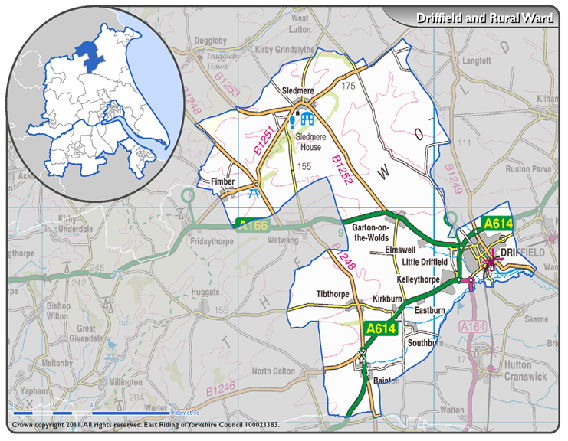

AREA COVERED BY EAST WOLDS & COASTAL TEAM



